**STUDY OF A MANUFACTURING FACILITY**

**SYSC 5001**

**Project Deliverable 3**

**Advisor:**

Prof. Chang Cheng Huang

Dept. of Systems and Computer Engineering

Carleton University

**Group 101:**

101206784 Abdul Mutakabbir

# Model Verification and Validation:

## Conceptual Model:

A manufacturing facility assembles three different types of products (P1, P2, P3) and having different components (C1, C2, C3) as follows:

* P1: C1
* P2: C1, C2
* P3: C1, C3

Two inspectors (I1, I2) clean and repair the components as follows:

* I1: C1
* I2: C2, C3 (Randomly)

The inspectors will never have to wait for components. There is an infinite inventory of them always immediately available.

There are three workstations in the facility, named W1, W2, and W3, which assemble products P1, P2, P3, respectively. After the components pass inspection, they are sent to their respective workstations. Each workstation has a buffer capacity of two components, with one buffer available for each of the component types needed. A product can begin being assembled only when components of all types required are available. If all workstation buffers for a specific type of component are full, the corresponding inspector who finished inspecting a component with the same type is considered “blocked" until there is an opening, at which time the inspector can resume processing and sending components of that type.

In the present mode of operation, Inspector 1 routes components C1 to the buffer with the smallest number of components in waiting (i.e., a routing policy according to the shortest queue). In the case of a tie, W1 has the highest and W3 the lowest priority.

## Parameters of Interest:

* Facility Throughput/ product throughput = Number of products produced / total simulation time
* Probability each workstation is busy = Number of minutes the workstation was bust / total simulation time
* Average buffer occupancy of each buffer = SUM(Occupancy of buffer each min) / total simulation time
* Probability that each inspector remains “blocked" = Total minutes the inspector was blocked / total simulation time

## Operational Model:

The flow chart for the model is given to verify it.

Class and object diagrams are also provided below.

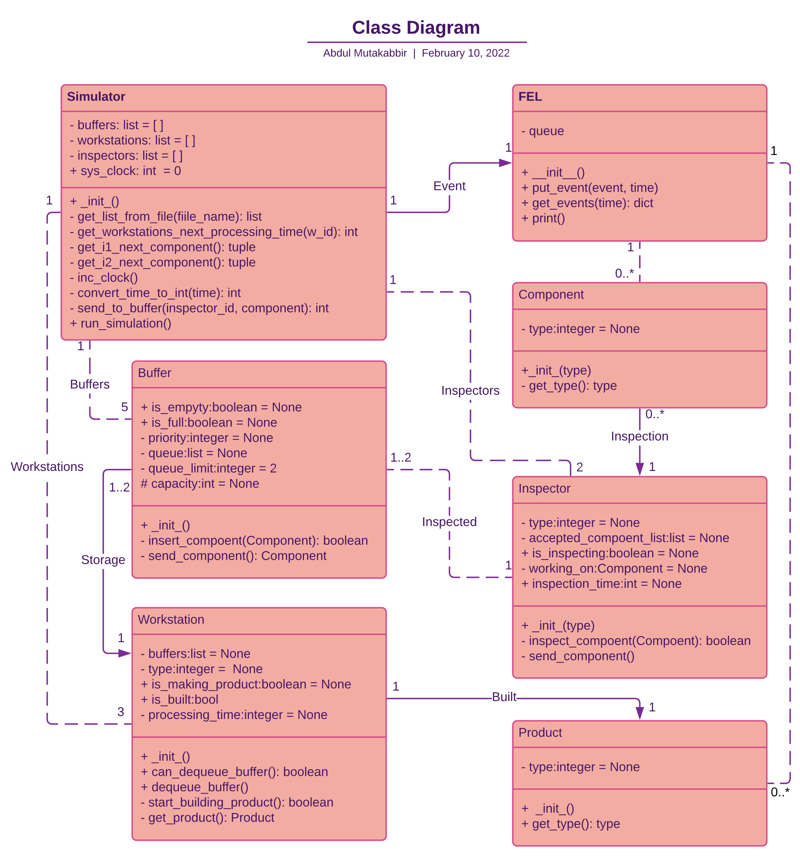

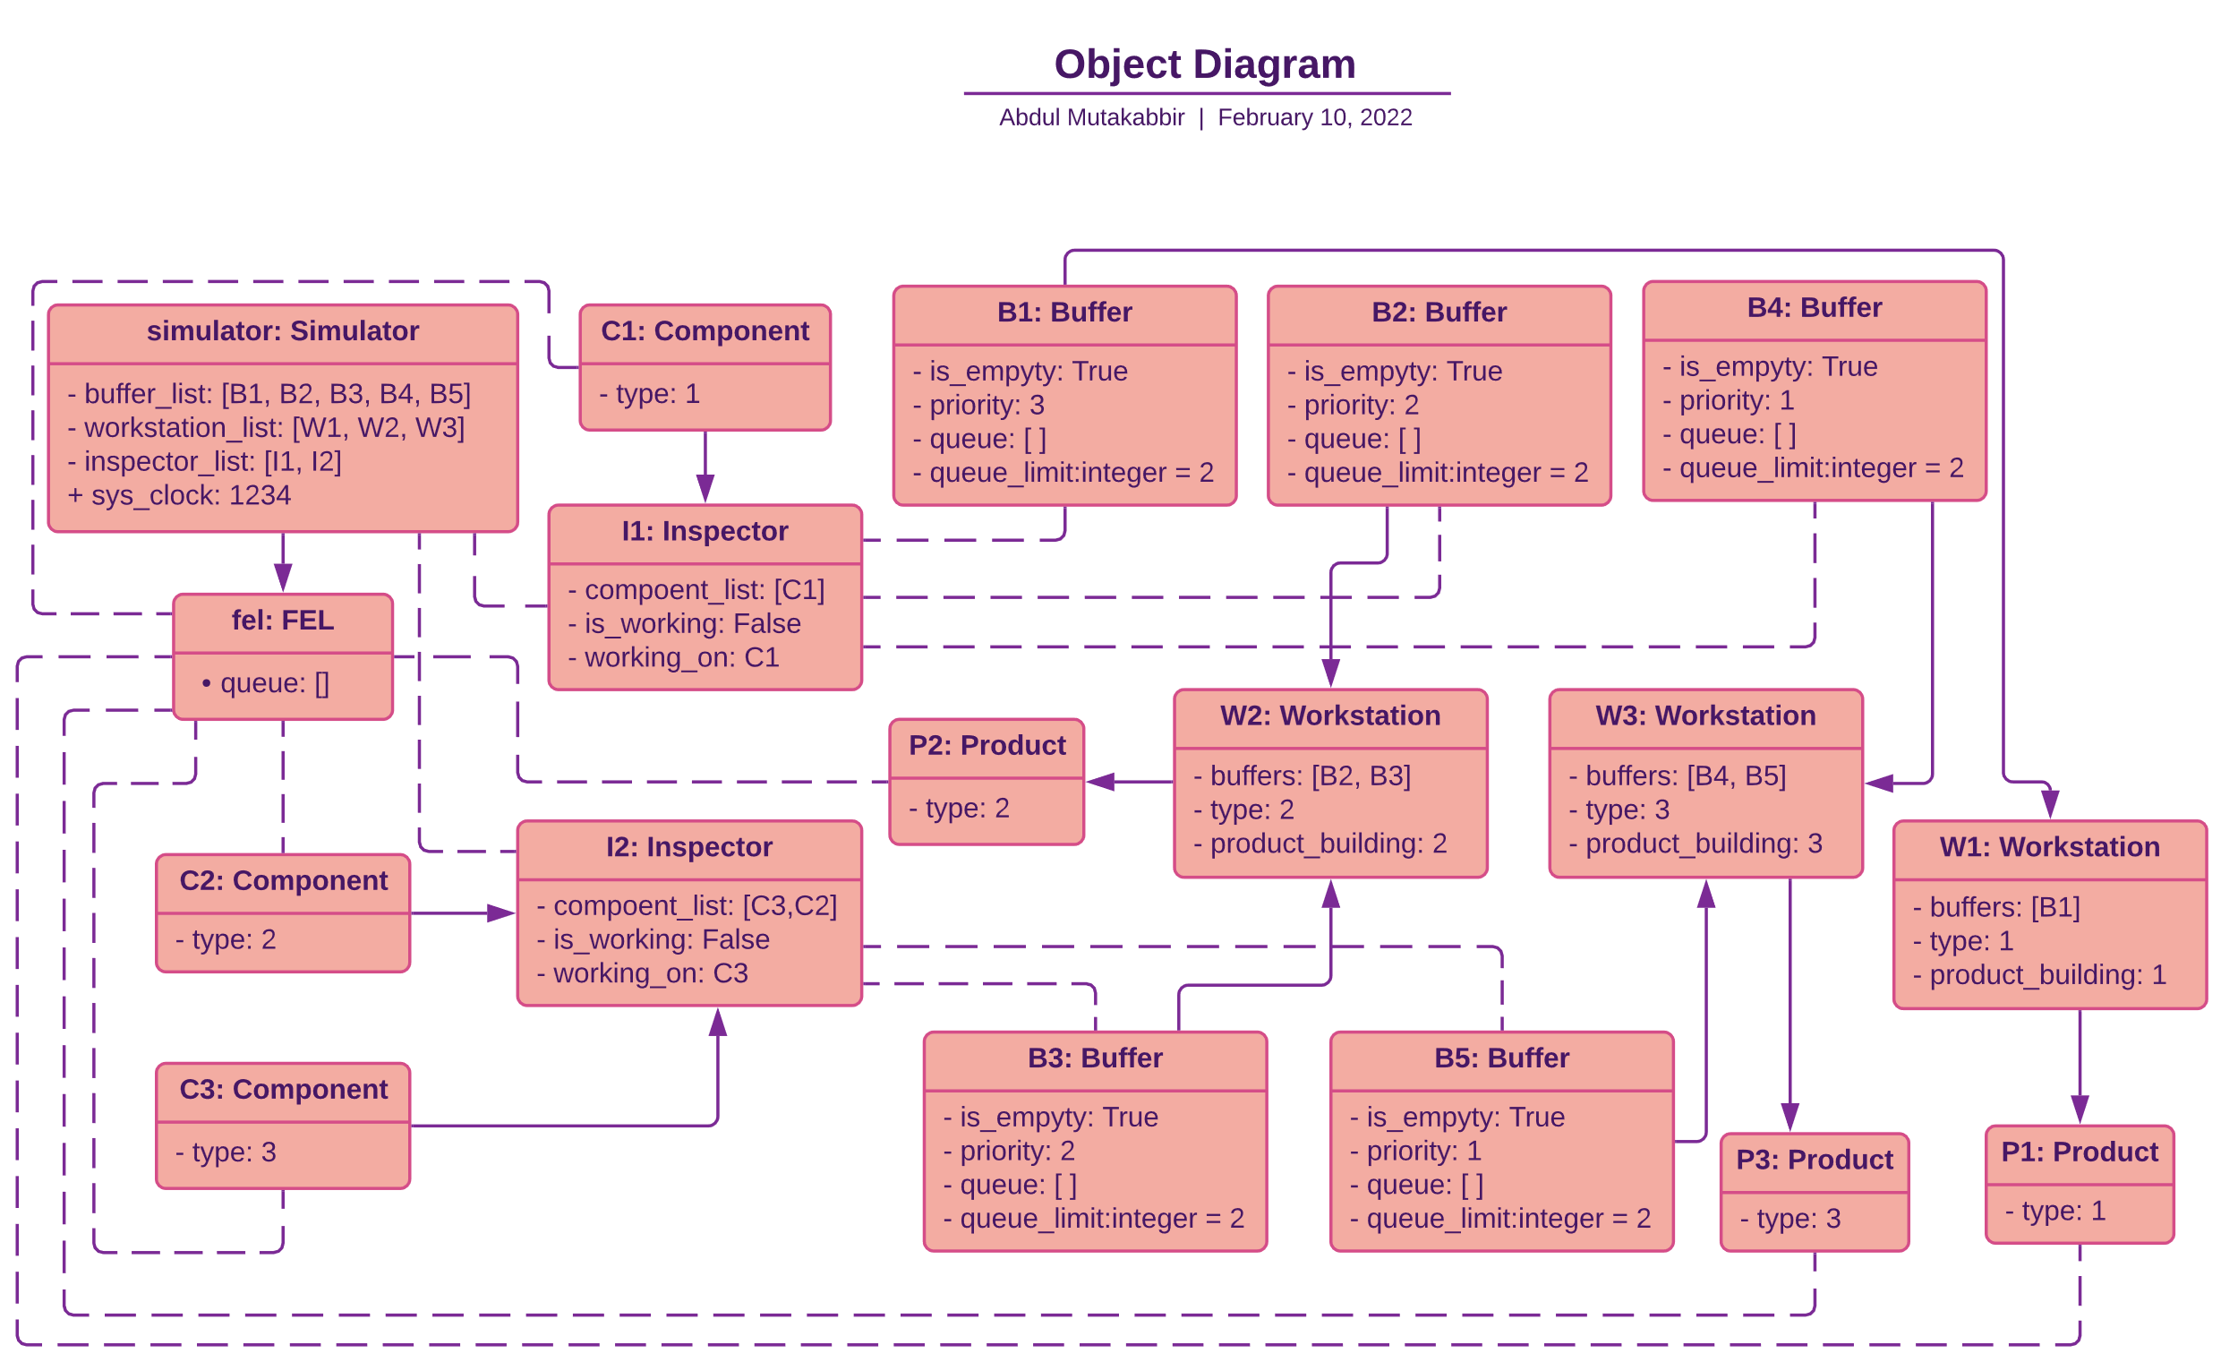

For other verifications like the histogram and QQ plot please refer to the Deliverable 2 document.

## Peer Review:

Peer review was not done for this as it is against the guidelines for the project submission. But this should be a step in the verification process.

## Trial Run:

The simulation was run for 899.999 minutes which produced the flowing result:

Product 1 throughput: 0.08777777777777777

Product 2 throughput: 0.003333333333333333

Product 3 throughput: 0.0022222222222222222

Workstation 1 busy probability: 0.42282888888888887

Workstation 2 busy probability: 0.022838888888888888

Workstation 3 busy probability: 0.037102222222222224

Workstation 1 wait time: 4817.037974683544

Workstation 2 wait time: 6851.666666666667

Workstation 3 wait time: 16696.0

Workstation 1 Component count: 79

Workstation 2 Component count: 3

Workstation 3 Component count: 2

Buffer 1 average occupancy: 0.13815222222222223

Buffer 2 average occupancy: 0.22326666666666667

Buffer 3 average occupancy: 0.44434666666666667

Buffer 4 average occupancy: 0.00544

Buffer 5 average occupancy: 1.5369333333333333

Inspector 1 block probability: 0.0

Inspector 2 block probability: 0.8402122222222222

## Validation:

As mentioned by the professor this part is hard to do.

But the alternative is to check if the model is working as it should by checking for the initialization phase.

And checking for face validity. This the model does satisfy.

The Histograms and QQ plot also validate the simulation.

## Little’s Law:

For this project, Littles law was tested on Production Run 8.

We found the following through the output of the simulation:

The average arrival rate into the system for Product 1, Product 2, Product 3 were 0.87, 0.3, 0.2 respectively.

Summing them up we get a total arrival rate of 0.92

Therefore, the average arrival rate into the system is 92

We also got the average waiting time for Workstations 1,2,3 as 42%, 2% 3% respectively, thereby getting an average wait time of 45%

Therefore, the average waiting time = 45%

The average number of products produced by workstations 1,2,3 is 38, 2, 2 respectively.

totaling to 42.

Therefore 42 ~ 45 * 0.92

= 42 ~ 41.4

Therefore the little laws hold true.

Also, the number of component 1 entering the system = 48 which matches the number of output products that could be produced.

Similarly for Component 2, 4 components entered the system, and 2 products were produced leaving 2 in the buffer. Same for Component 3.

# Production Runs and Analysis:

## Production Run 1:

**Stop point = 999.999 min.**

result:

Product 1 throughput: 0.088

Product 2 throughput: 0.003

Product 3 throughput: 0.002

Workstation 1 busy probability: 0.413563

Workstation 2 busy probability: 0.020555

Workstation 3 busy probability: 0.033392

Buffer 1 average occupancy: 0.124337

Buffer 2 average occupancy: 0.350719

Buffer 3 average occupancy: 0.336121

Buffer 4 average occupancy: 0.104896

Buffer 5 average occupancy: 1.436362

Inspector 1 block probability: 0.0

Inspector 2 block probability: 0.856191

## Production Run 2:

**Stop point = 499.999 min.**

result:

Product 1 throughput: 0.08

Product 2 throughput: 0.0

Product 3 throughput: 0.0

Workstation 1 busy probability: 0.24756

Workstation 2 busy probability: 0.0

Workstation 3 busy probability: 0.0

Buffer 1 average occupancy: 0.05556

Buffer 2 average occupancy: 0.0

Buffer 3 average occupancy: 0.6952

Buffer 4 average occupancy: 0.0

Buffer 5 average occupancy: 0.0

Inspector 1 block probability: 0.0

Inspector 2 block probability: 0.0

## Production Run 3:

**Stop point = 99.999 min.**

result:

Product 1 throughput: 0.1

Product 2 throughput: 0.0

Product 3 throughput: 0.0

Workstation 1 busy probability: 0.24609

Workstation 2 busy probability: 0.0

Workstation 3 busy probability: 0.0

Buffer 1 average occupancy: 0.09514

Buffer 2 average occupancy: 0.28611

Buffer 3 average occupancy: 0.0

Buffer 4 average occupancy: 0.0

Buffer 5 average occupancy: 0.0

Inspector 1 block probability: 0.0

Inspector 2 block probability: 0.0

## Production Run 4:

**Stop point = 799.999 min.**

result:

Product 1 throughput: 0.09125

Product 2 throughput: 0.0037500000000000003

Product 3 throughput: 0.0

Workstation 1 busy probability: 0.4063125

Workstation 2 busy probability: 0.02569375

Workstation 3 busy probability: 0.02747875

Buffer 1 average occupancy: 0.13366625

Buffer 2 average occupancy: 0.1883975

Buffer 3 average occupancy: 0.42015375

Buffer 4 average occupancy: 0.0

Buffer 5 average occupancy: 1.71247625

Inspector 1 block probability: 0.0

Inspector 2 block probability: 0.82023875

## Production Run 5:

**Stop point = 699.999 min.**

result:

Product 1 throughput: 0.08571428571428572

Product 2 throughput: 0.004285714285714285

Product 3 throughput: 0.0

Workstation 1 busy probability: 0.3869457142857143

Workstation 2 busy probability: 0.029364285714285714

Workstation 3 busy probability: 0.0

Buffer 1 average occupancy: 0.10047

Buffer 2 average occupancy: 0.07245428571428572

Buffer 3 average occupancy: 0.48017857142857145

Buffer 4 average occupancy: 0.0

Buffer 5 average occupancy: 1.702807142857143

Inspector 1 block probability: 0.0

Inspector 2 block probability: 0.7945585714285714

## Production Run 6:

**Stop point = 899.999 min.**

result:

Product 1 throughput: 0.08777777777777777

Product 2 throughput: 0.003333333333333333

Product 3 throughput: 0.0022222222222222222

Workstation 1 busy probability: 0.42282888888888887

Workstation 2 busy probability: 0.022838888888888888

Workstation 3 busy probability: 0.037102222222222224

Buffer 1 average occupancy: 0.13815222222222223

Buffer 2 average occupancy: 0.22326666666666667

Buffer 3 average occupancy: 0.44434666666666667

Buffer 4 average occupancy: 0.00544

Buffer 5 average occupancy: 1.5369333333333333

Inspector 1 block probability: 0.0

Inspector 2 block probability: 0.8402122222222222

## Notes:

The number of replications is enough as we can get the initialization phase from these replications. One more thing is that these replications produce consistent results for the output.

## Initialization Phase:

The initialization Phase for the simulation is between 800 to 900 minutes for product 3 as that is the minimum amount of time it takes for the system to produce any output for product 3. For product 2 the initialization phase is between 500 and 600 minutes as it minimum amount of time it took to build at least one quantity of that product. For Product 1 the initialization phase is between 50 min and 100 min.

## Confidence Interval:

The confidence interval is given by the formula:

Where x is the mean, z-value for the confidence level, n is the sample size, s is the standard deviation.

##### Inspector 1:

X = 10.35

Z = 1.96 for 95% confidence

S = 9.78

n = 300

Therefore CI = [9.24,11.45]

##### Inspector 2 for Component 2:

X = 15.53

Z = 1.96 for 95% confidence

S = 14.68

n = 300

Therefore CI = [13.87,17.19]

##### Inspector 2 for Component 3:

X = 20.63

Z = 1.96 for 95% confidence

S = 19.85

n = 300

Therefore CI = [18.38,22.87]

##### Workstation 1:

X = 4.60

Z = 1.96 for 95% confidence

S = 4.75

n = 300

Therefore CI = [4.60,5.13]

##### Workstation 2:

X = 11.09

Z = 1.96 for 95% confidence

S = 11.84

n = 300

Therefore CI = [9.66,12.42]

##### Workstation 3:

X = 8.79

Z = 1.96 for 95% confidence

S = 8.65

n = 300

Therefore CI = [7.81, 9.76]

Note: I am guessing he wants us to do more but that part is missing the project document so can’t help it.